**ITECH DIGITAL PRODUCTIONS**, Inc

I-Tech Digital Productions Inc. Now a full pledge digital and multimedia company started as services and trading previously known as I-Tech Digital Systems & Trading. A company that provides auxiliary supply and services on sales and rental of high luminal LCD Projectors, screens in different sizes and other audiovisual equipment. Through years of experience as a fast growing company in live events, ITECH DIGITAL PRODUCTIONS, Inc. officially incorporated itself to cater almost any kinds of professional video and broadcast production, event managements, professional light and sound services rental and reinforcement, stage backdrop designs that makes us a “complete visual -audio- graphics events and production provider” in the Philippines.

Our versatility and innovativeness to become centralized one-stop solution on events management and audio visual reinforcement makes I-tech a complete solution of technology and expertise with quality, superiority and integrity in very cost efficient way.

Our aim is not only to provide state of art equipment but to give exceptional quality of service by well-disciplined and trained technicians with our unsurpassed dedication to make our job done in exceptional quality, arts and courtesy.

With respect to Production Set-up, our company can provide a full package that can suit your company’s need, from press-conference to the big event itself. We have an access to a wide array of talents from Ace Videographers that has an experience in Television Network Coverage, to Live Event / Streaming, and even simple documentations, to Technical Directors that can handle each and every aspect of your Audio Visual Presentations, to Stage Managers with all the Production Designs, our company we’ll surely be utilized just to deliver a quality product, which is our continuing drive to perfection.

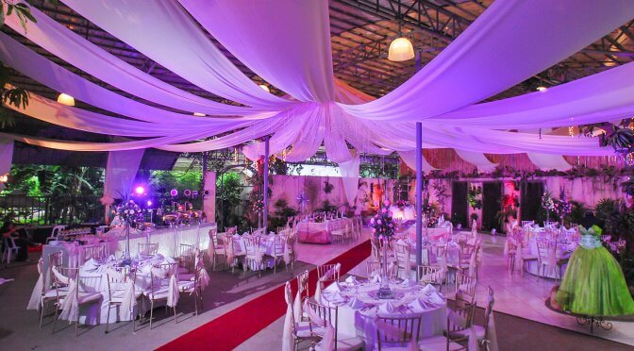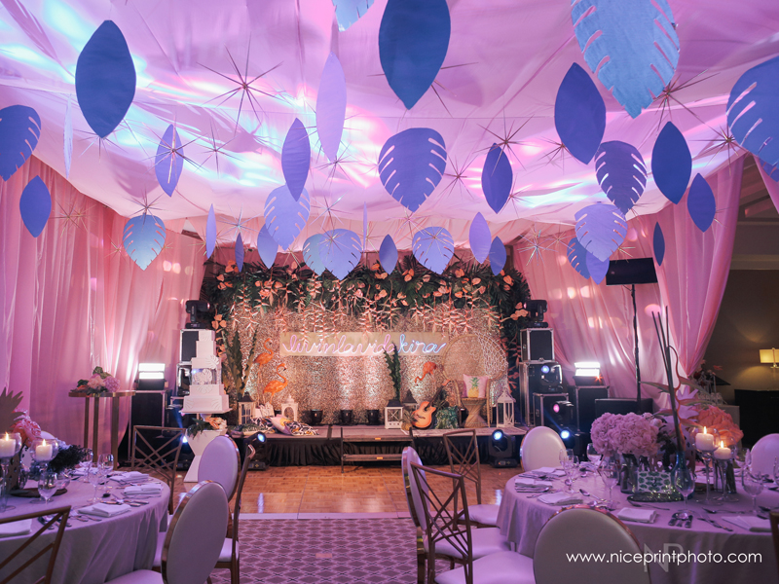

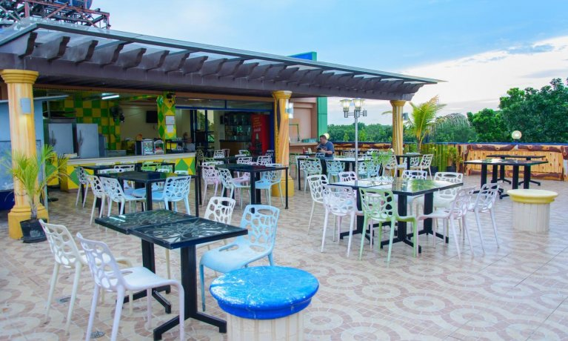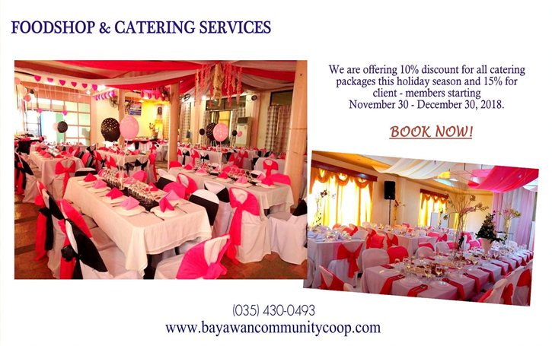

C & L Top-View Venue Bayawan Community Cooperative

